Bahria University,

Karachi Campus

LAB EXPERIMENT NO.

______

LIST OF TASKS

|  |  |
| --- | --- |
| TASK NO | OBJECTIVE |
|  |  |
| 1 | Add constant -001 from user input, |
| 2 | sub constant 5 from user input. |
| 3 | Add two numbers by taking input from user. |
| 4 | Add two constant numbers. |

Submitted On:

(Date: DD/MM/YY)

**TASK 1 #:** Add constant -001 from user input.

**INPUT:**

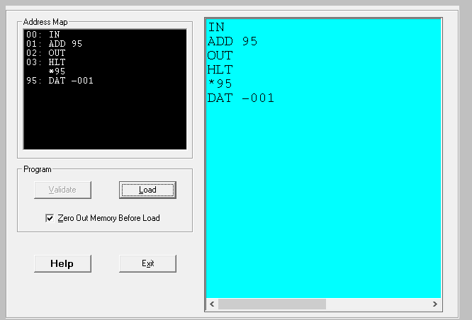

**OUTPUT:**

**TASK 2 #:** sub constant 5 from user input.

**INPUT:**

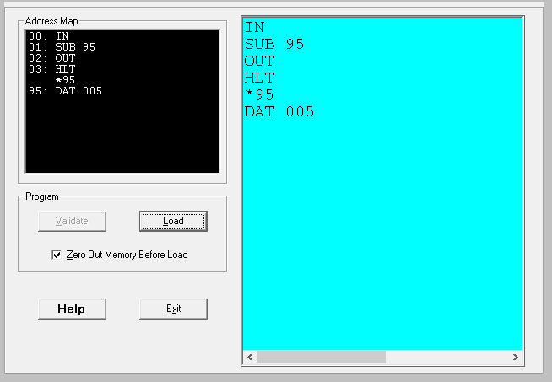

**OUTPUT:**

**TASK 3#:** Add two numbers by taking input from user.

**INPUT:**

**OUTPUT:**

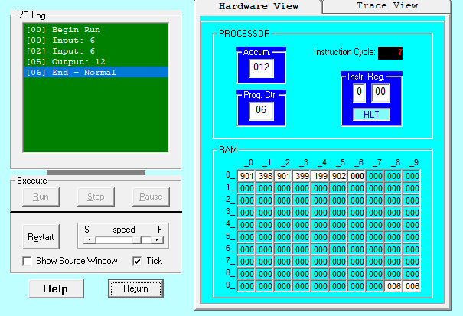

**TASK 4 #:** Add two constant numbers.

**INPUT:**

**OUTPUT:**

